 | Filing Reference : |  | GG/COMS/TS.2/20
 | Document Title : |  | Use-Case Realization Report (Analysis)  View and Print Cylinder Information
 | Version : |  | 1.0
 | Prepared By : |  | Koh Ming Jin
 | Date Created : |  | Monday, Apr 29th, 2011
Approved By :
 |  | Tran Ba Tien |  | Date
 |  | Project Manager |  | 29th Apr 2011
©2011 [Hoang Kim joint stock Company].
The information contained in this document is the property of [Hoang Kim joint stock Company]. The contents must not be reproduced, wholly or in part, for purposes other than for which it has been supplied, without the prior permission of [Hoang Kim joint stock Company], or, if it has been furnished under contract to another party, as expressly authorised under that contract. [Hoang Kim joint stock Company] shall not be liable for any errors or omissions.

Revision History
Date | Version | Description | Author
29/Apr/2011 | 1.0 | Initial Document | Koh Ming Jin

Table of Contents
1. Brief Description 4
2. Flow of Events 4
2.1 Standard Flow 4
2.1.1 Log-In 4
2.1.2 User Functions 4
2.1.3 Log-Out 4
2.2 Exception 4
3. Interaction Diagrams 5
3.1 Collaboration Diagram for View Cylinder Information 5
4. Participating Objects 5
4.1 Main Page 5
4.2 Role Main Page 5
4.3 Main Controller 5
4.4 Cylinder Controller 5
4.5 Cylinder 6
5. Class Diagrams 6
5.1 Domain Class Diagram: View & Print Cylinder Information 6
6. Derived Requirements 6

Use-Case Realization Report
View & Print Cylinder Information

Brief Description
This use case enables an operation manager to view and print a cylinder information record.

Flow of Events
The standard flow of events for this use case and any exceptions are described in the following subsections. See section 3.1 for an overview of the participating Actors and Domain Objects.

Standard Flow
The flow of events is described as follows:

Log-In
To commence using the system, the Operation Manager is required to log-in successfully as follows:
- Refer to Log In Use Case for details.

User Functions
- The use case starts when Operation Manager selects the View Cylinder Information option of the MainPage(operation initiate). This will redirect to the RoleMainPage.
- The operation viewCylinderInfo will be invoked.
- The RoleMainPage, which includes all the Cylinder Information details, is displayed. The information are retrieved by calling the operation viewCylinderInfo of MainController and CylinderController.
- The RoleMainPage will be refreshed to display the cylinder information.
- The Operation Manager has the option to click on the cylinder ID to view more details about the particular cylinder.
- Once the Operation Manager clicks on print option, the printer will start to print the cylinder information (operation print).
- The use case terminates.

Log-Out
- The Operation Manager will terminate use of COMS (ie: log-out) by pressing a button with the caption “Log Out”.
- Refer to the Log Out Use Case for details.

Exception
- If the system is not able to retrieve the cylinder information, an error message will be displayed. This will instruct the actor to contact the administrator.

Interaction Diagrams

Collaboration Diagram for View Cylinder Information
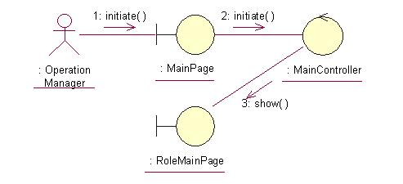
The above collaboration diagram shows the process flow after the actor has login.
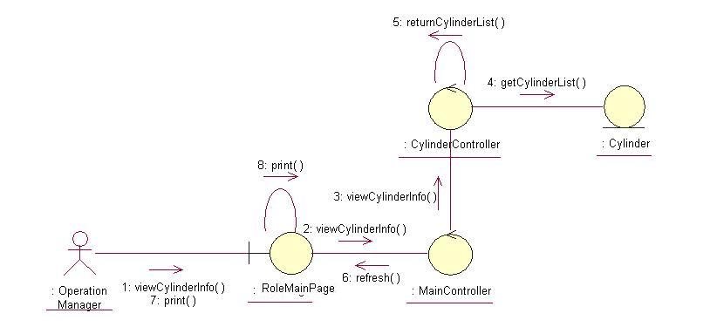
The above collaboration diagram shows the main process flow of this use case.

Participating Objects

Main Page
This object renders the contents after the actor has login. The Director, Department Manager and Operation Manager actors use this object.

Role Main Page
This object renders the contents (based on the user role) after the actor has login. The Director, Department Manager and Operation Manager actors use this object.

Main Controller
This object acts as the middleman between Main Page and the Cylinder Controller. It will translate interactions with the view into actions to be performed by the Cylinder Controller.

Cylinder Controller
This object acts as the middleman between “View Cylinder Information” Page and the Cylinder object. It will translate interactions with the view into actions to be performed by the Cylinder object.

Cylinder
This object stores the details concerning the cylinder information of the COMS.

Class Diagrams

Domain Class Diagram: View & Print Cylinder Information
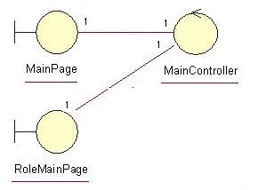
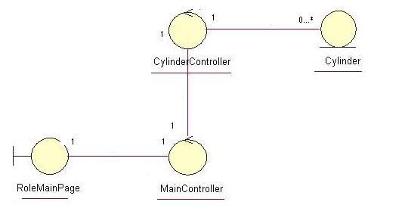

Derived Requirements
The Operation Manager PC keyboard and mouse will be used to retrieve Cylinder Information details (if any) and view all the system responses.

